**User guide**

Contents

1. Home

The home page is displayed when the program is opened. The Home page allows user to access Create tour, Make reservation, Find reservation / tour and displays the list of tours.

On the following pages it will be elaborated all the functions of the program.

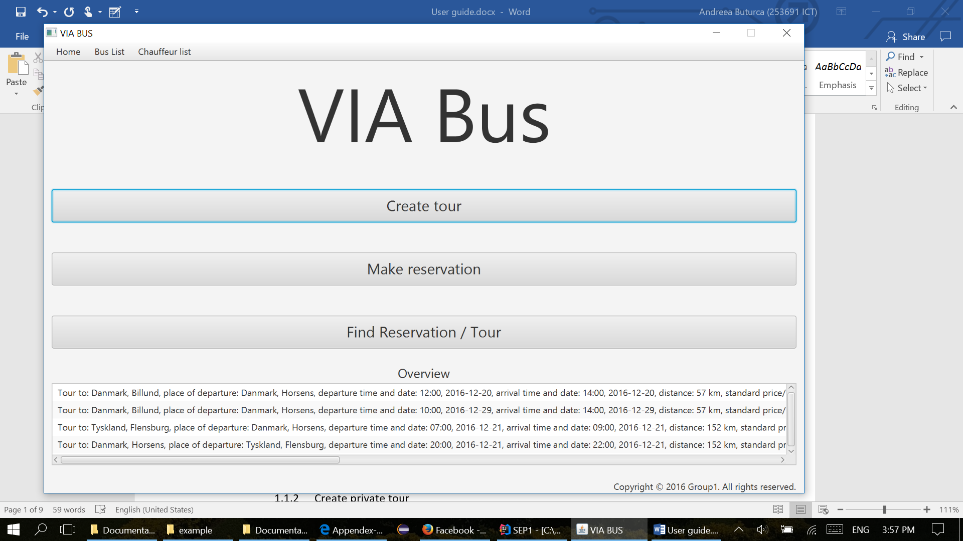

* 1. Create tour
     1. Create tour – standard

The user must fill in all the dates about start time(format example 10:00), date of the departure (can be picked up or filled in with the following format : month/day/year: 12/01/2016), end time and date of the arrival, the departure place, destination place, distance in km, the buss type can be choosen from the list, price. The chauffeur list is sorting after user enters the date, time, and after the bus type is selected. The bus list is sorting after user selects the bus type. In order to create a new Tour, the user must select a chauffeur and a bus from the lists. In case one of the fields is not filled in, an alert window will be displayed on the screen with the name of the field that should be filled in properly.

The check boxes for extra services and adding stops fields are not mandatory.

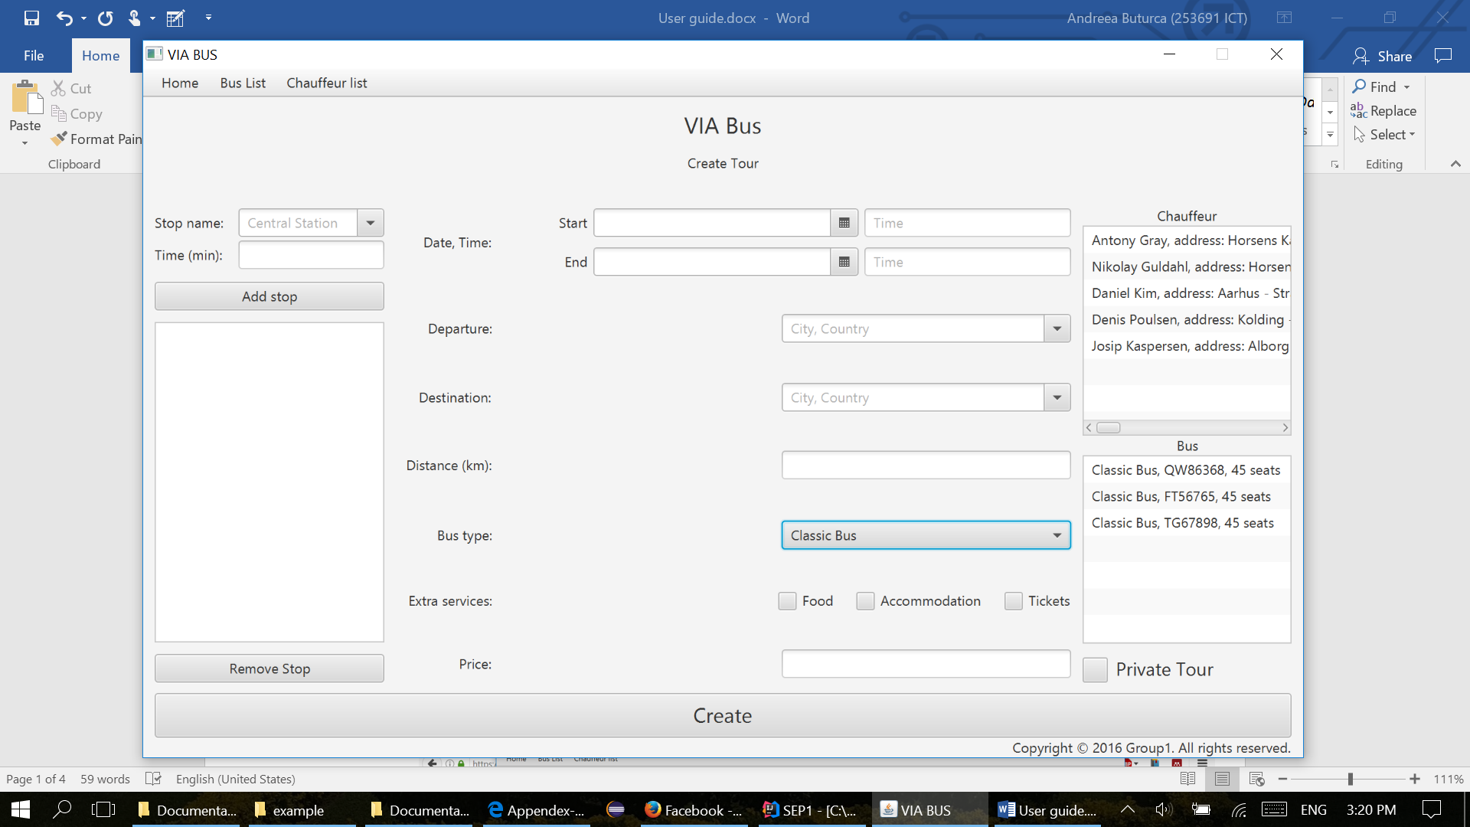

In order to finish creating a new tour, the user must press the Create button and an alert window will appear on the screen, like the one displayed bellow.

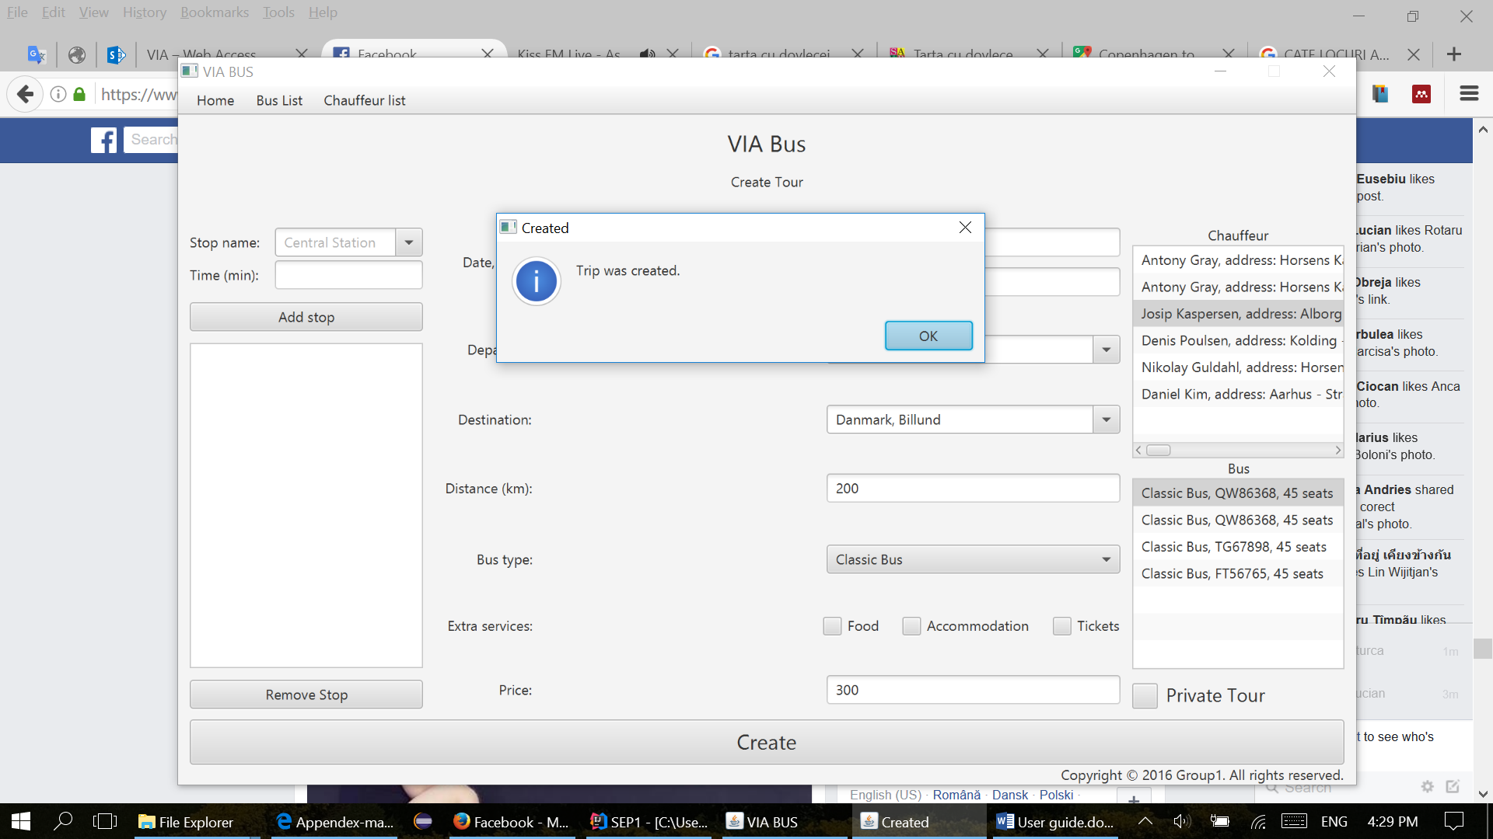

* + 1. Create private tour

If the user wants to create a private tour, he must follow the steps from Create tour, and press at the end the button Private Tour.

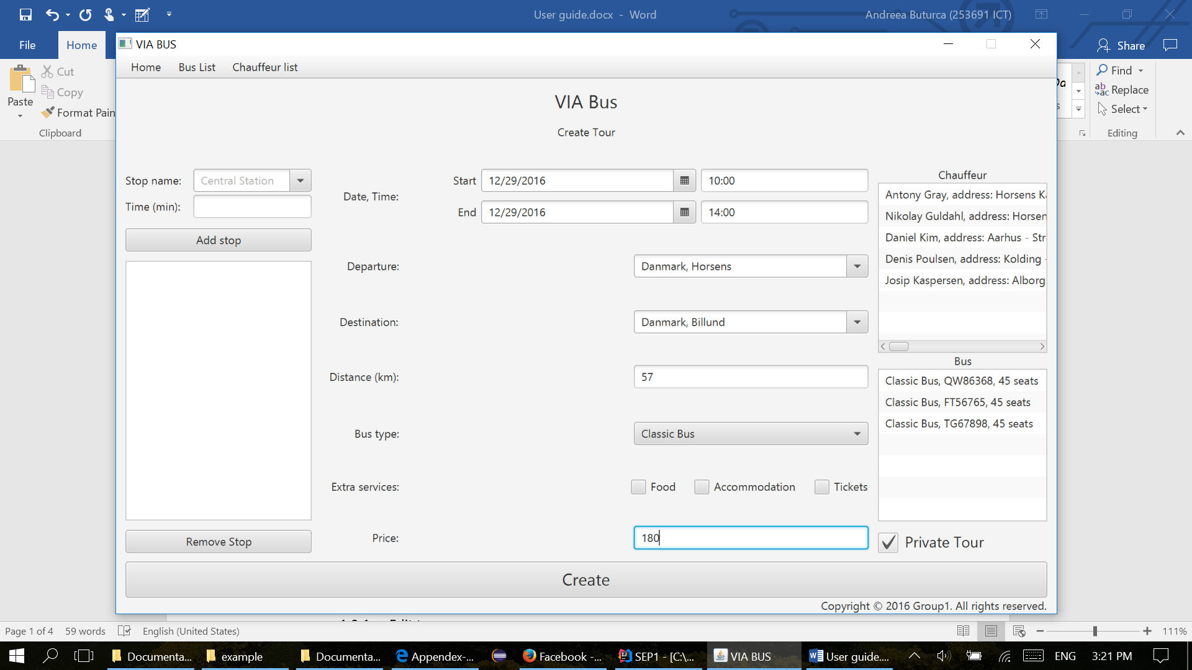



After this, another window will appear on the screen with: Fill data about customer.

This window will enable the user either to choose from the list of customers displayed on the right side of the window, or to fill in all the dates about customer: name, company name(only if the order is made by a company), address, email, phone number.

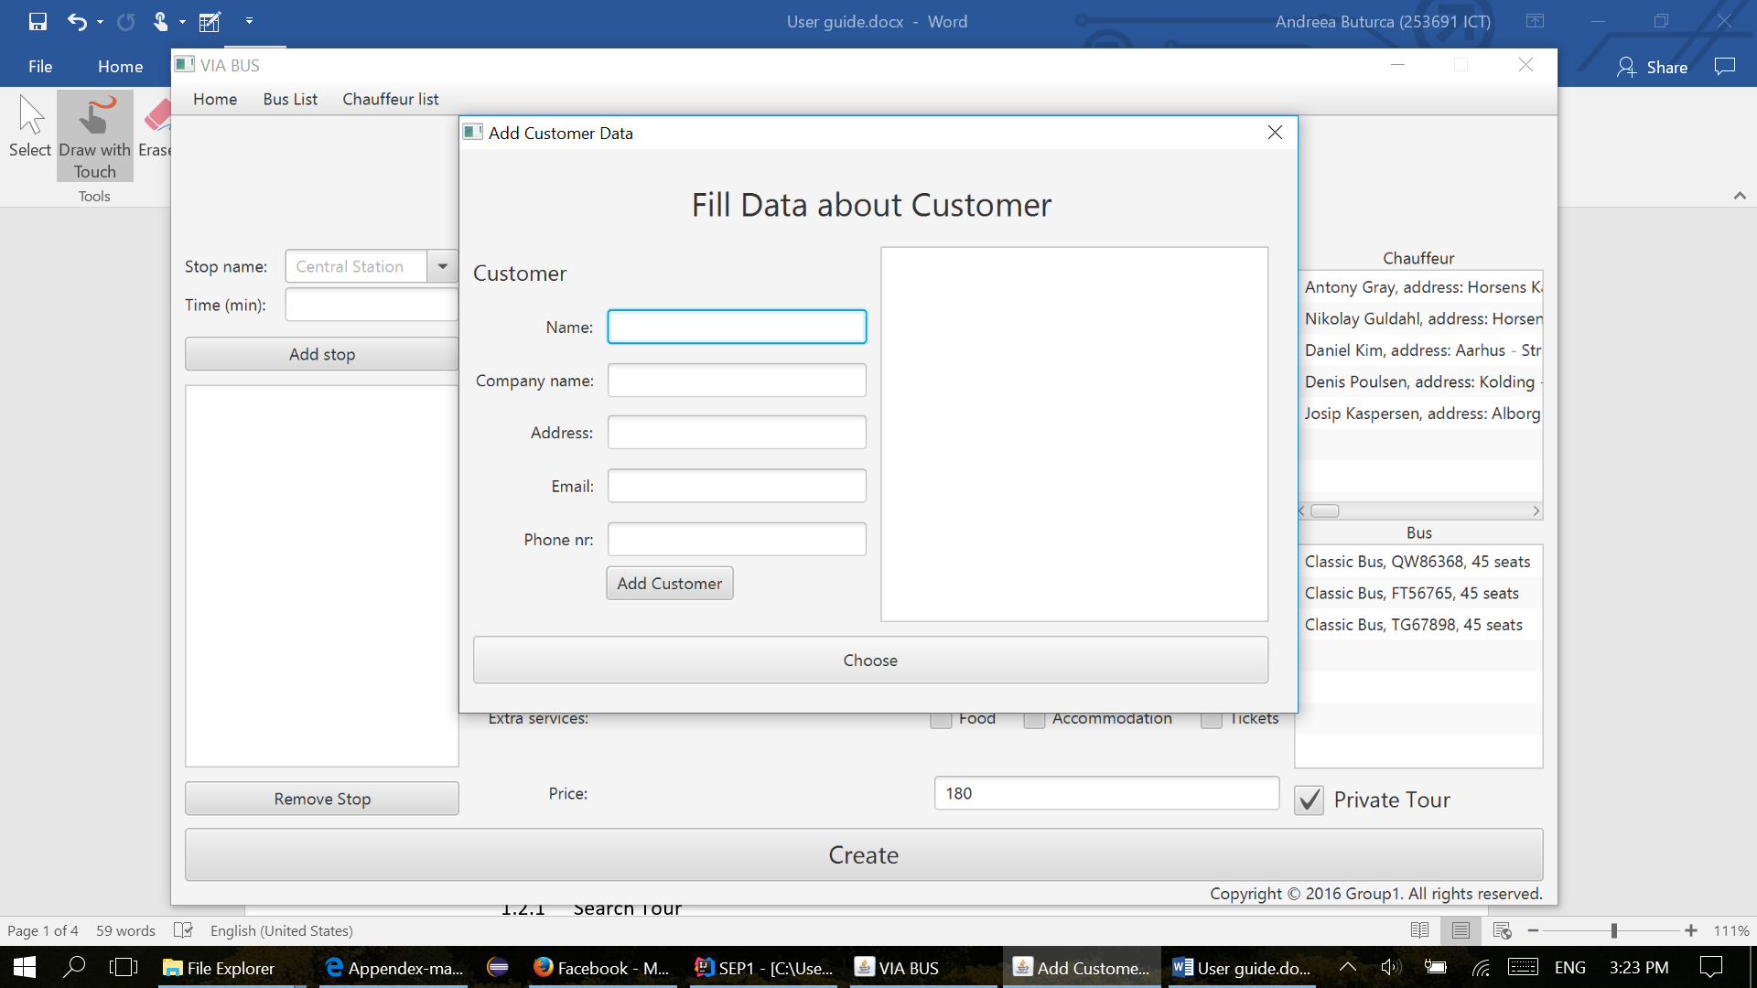

If the user doesn’t fill all the mandatory fields about the customer, an alert window will appear, like the one below, indicating which field must be filled in properly.

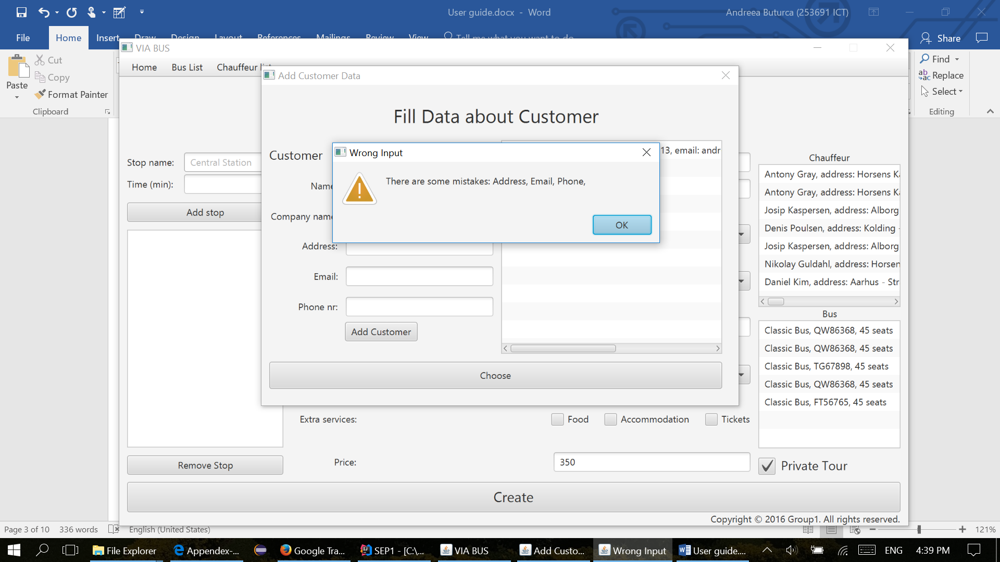

* 1. Make reservation

Make reservation appears in the Home tab, on the third place of the list.

* + 1. Make reservation - Search Tour

The screen Make reservation it’s split in 3 sections. First section has three fields used to search in the list of tours with the following parameters: destination, departure, number of passengers. The user can pick either one, or all the fields in order to find the best tour, according to customer requirements.

Second section, it enables the user to make notes in the right side of the screen, by simply clicking on the text field and typing in. The notes will automatically appear in the next step of making reservation, with the same data, only if the user typed into the note section. Notes are a convenient way of storing information which the user needs in the workspace.

The third section of this screen is the list of the Tours displayed in the bottom of the screen. The list is updated automatically according to the searches made by the user.

Before the user presses the button Choose tour, he must select a tour from the list.

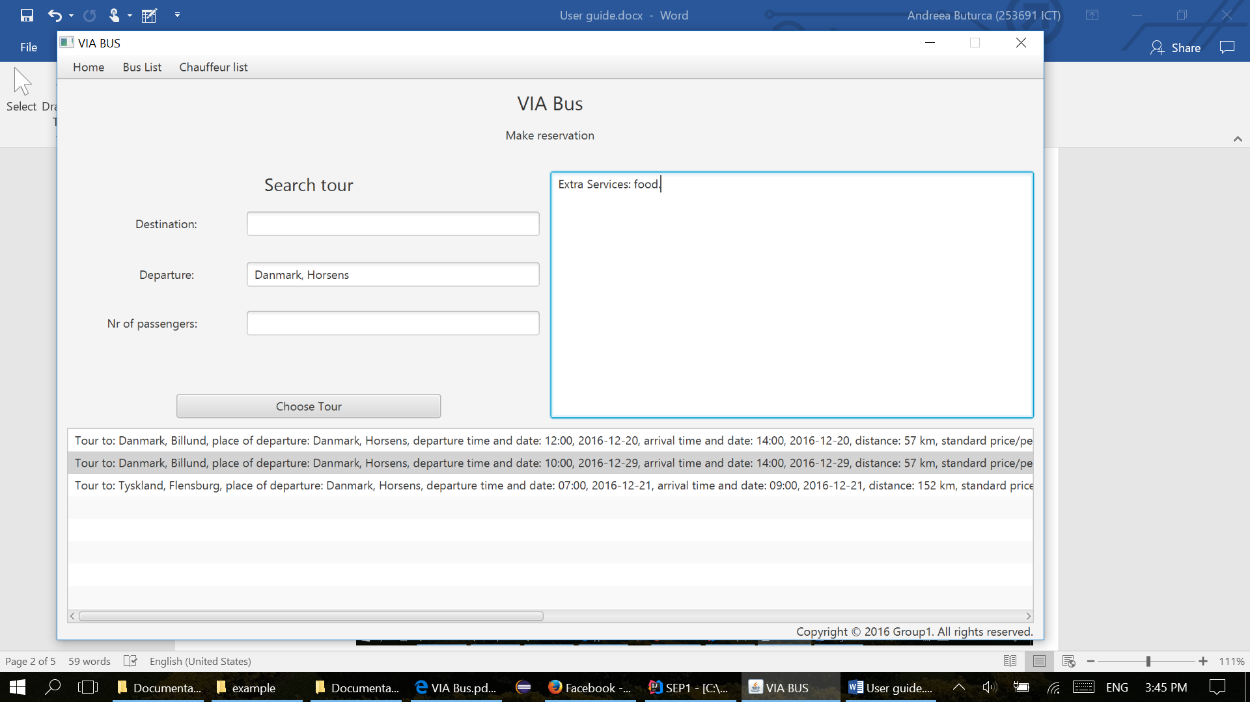

* + 1. Make reservation

The user must must select the customer, from the list of customers, wich is dispalyed under the Customer section, otherwise he must fill in all the dates about the customer, if the customer is at the first order, with the following dates: name, company name, address, email, phone number. All the fields about customer are mandatory, the field company name must be filled in, only if the order is made by a company.

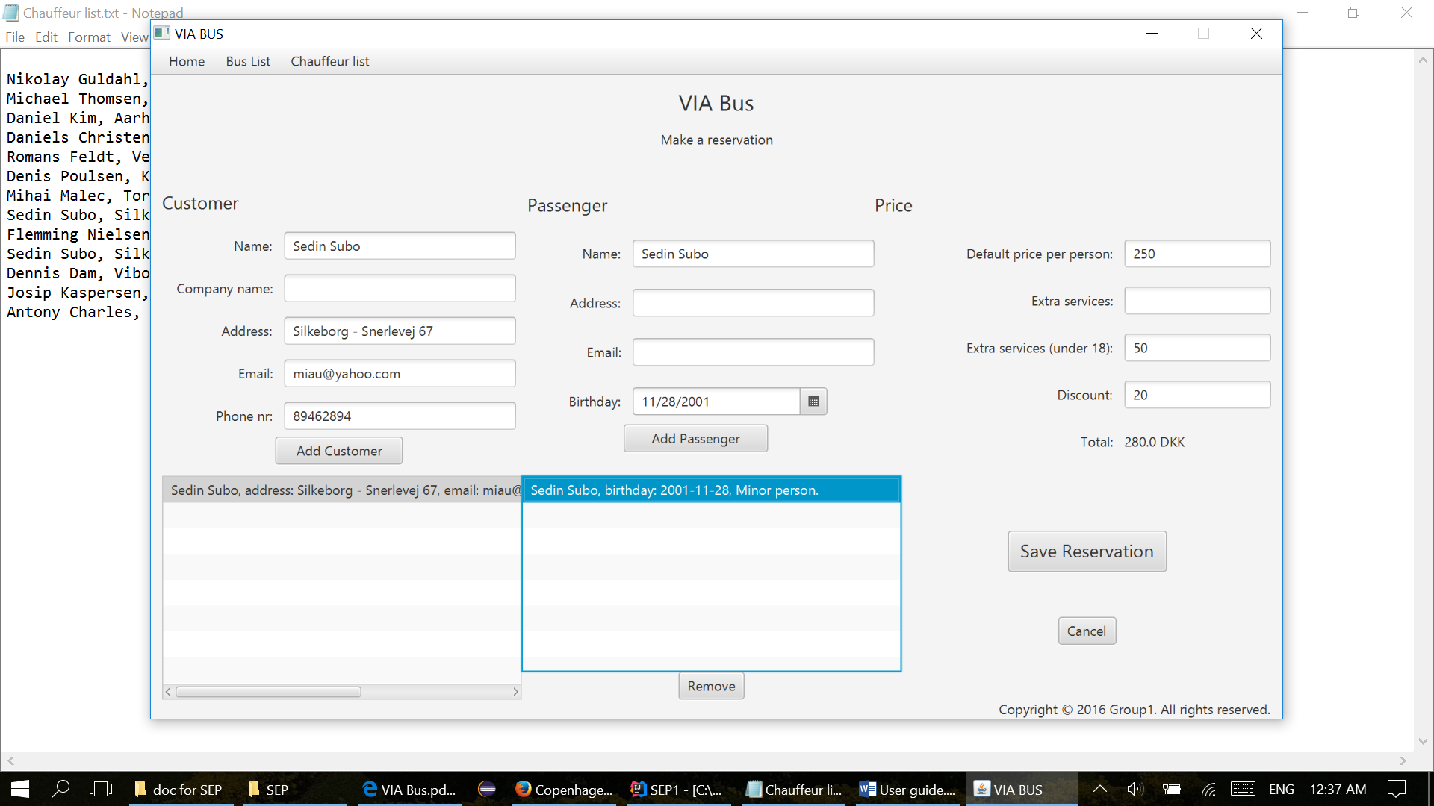

The next step in “Making a reservation” is to add the passengers, one by one, by pressing Add passenger. Each passenger will appear in the list of passengers displayed under the passenger section. The fields name and birthday are mandatory. The fields address and email are used only if the customer wants to give more details to receive the newsletter.

The next step is to fill in the price per person for extra services. Remark that the field default price per person is already filled in with the price took from the selected tour field.

The user will adjust the price for extra services according to the notes he took in step 1 of “Make a reservation”. This notes appear like in the picture displayed bellow. The user can also give a discount to the customer if necessary in the field called Discount.

All the prices must be typed in per person and the total price of the reservation will appear in the Total section.

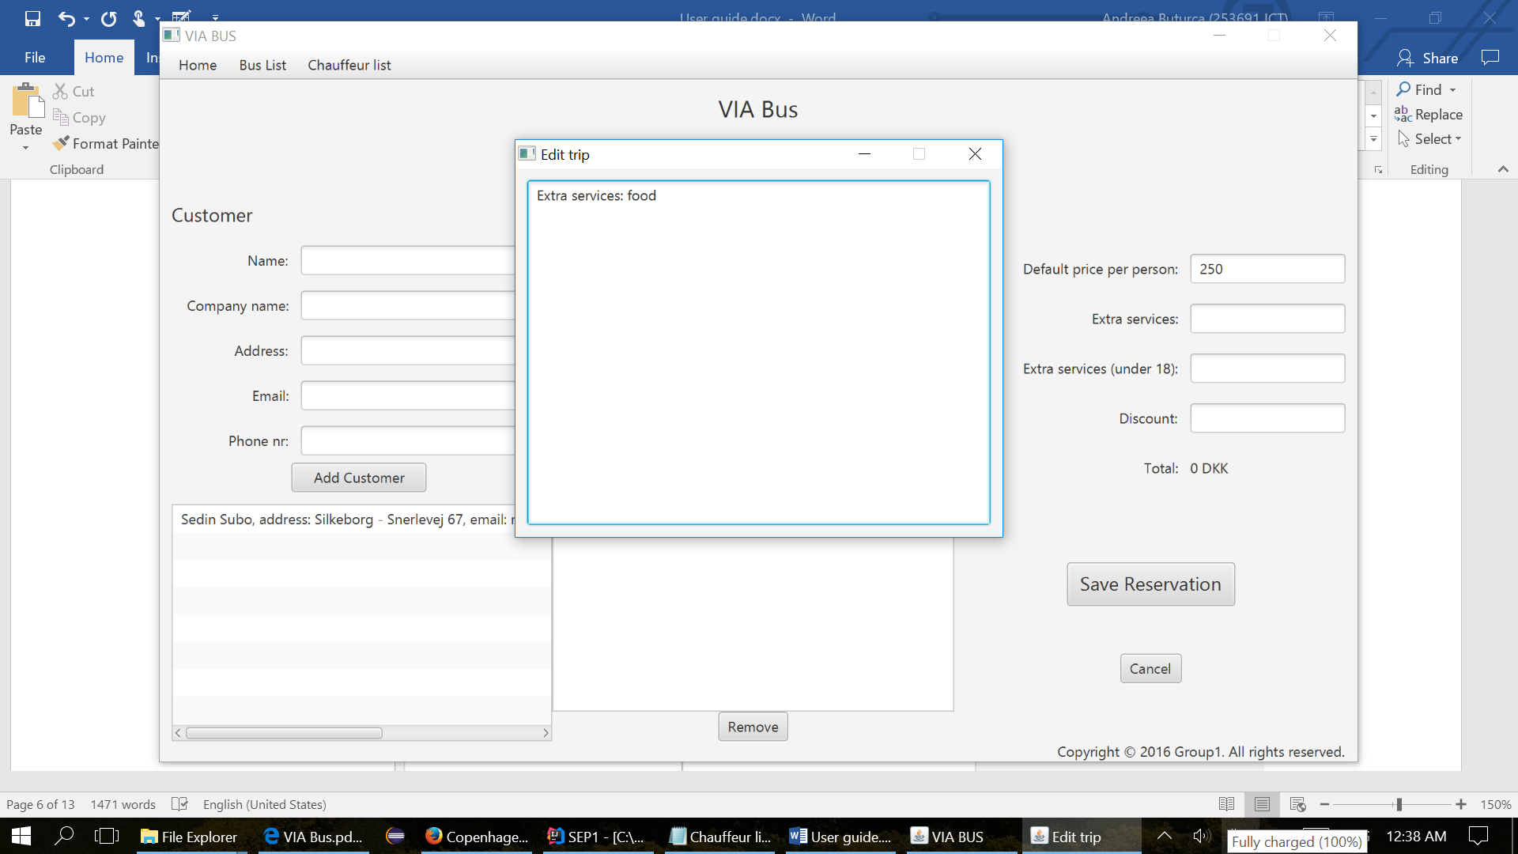

The user can any time press cancel reservation, and he will be directed to the home screen.

After all the steps enumerated above, the user can save the reservation, and an alert window will appear on the screen, which will confirm that the reservation was created.

The alert window will be exactly like the one displayed bellow.

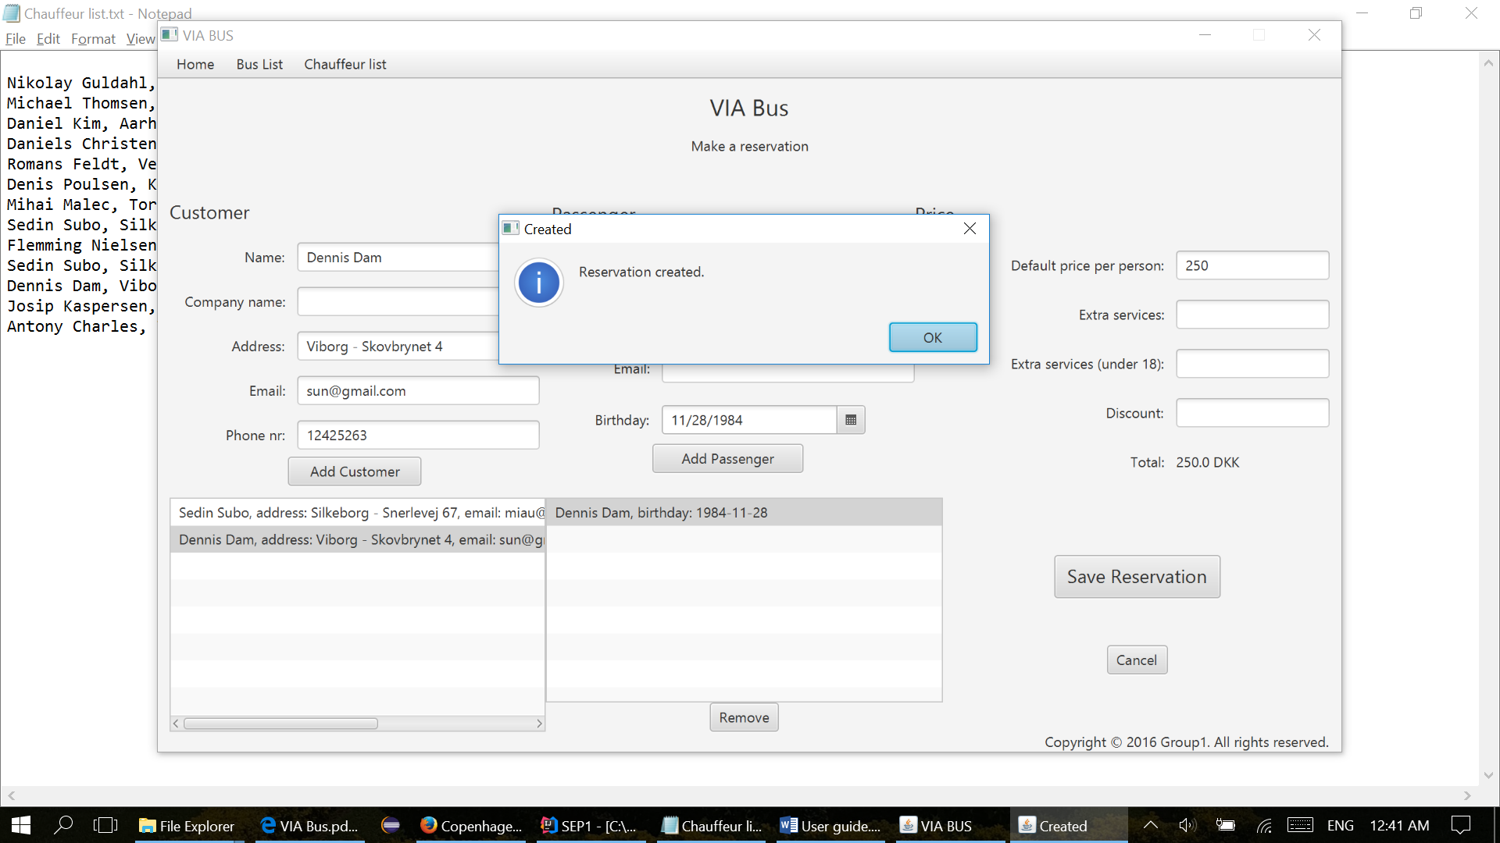

* 1. Find Reservation/Tour

Find Reservation/Tour appears in the Home tab, on the last place of the list. The screen it’s split in 2 sections, the left half of the page, is for Tours and the right half of the page is for Reservations.

The tour section, has three fields used to search in the list of tours with the following parameters: destination, departure, and date. The user can use either one, or all the fields in order to find the tour, according to customer requirements. And, three radio buttons for all tours, standard or private tours. The list is updated automatically according to the fields used by the user.

In order to go on edit tour or remove tour, the user must select one from the list.

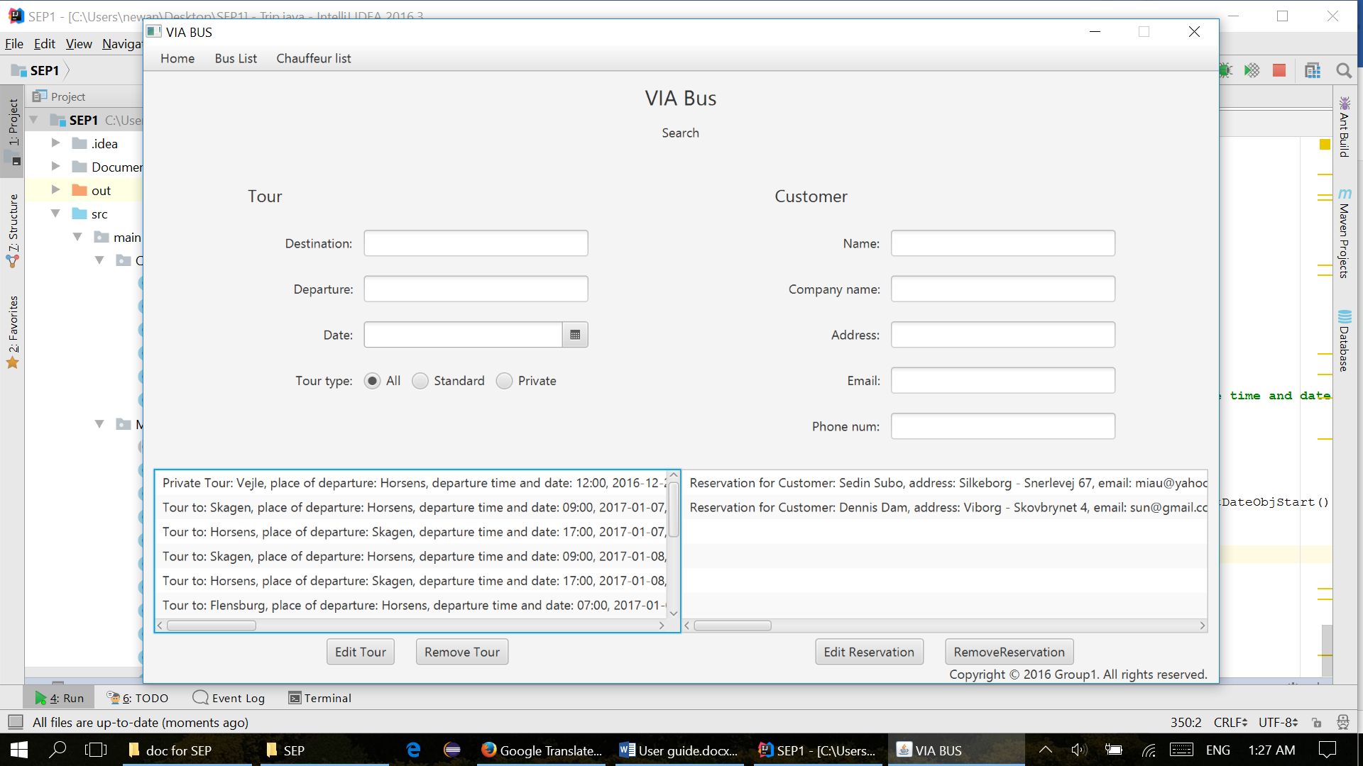

The Reservation section, has five fields used to search in the list of reservations with the following parameters about the customer that made the reservation: name, company name, address email, phone number. The user can use either one, or all the fields in order to find the right reservation. The list is updated automatically according to the fields used by the user.

In order to go on edit reservation or remove reservation, the user must select one from the list.

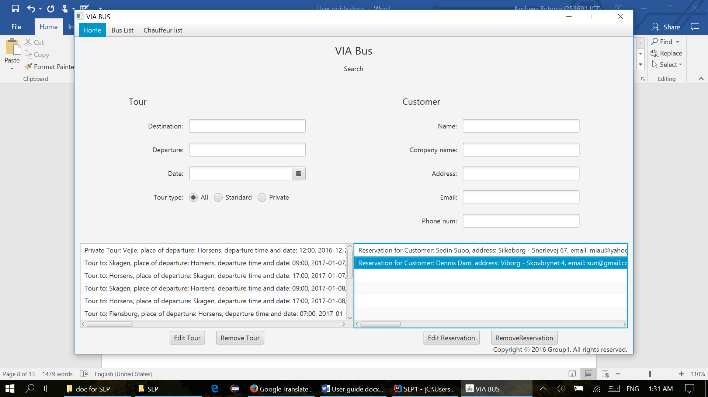

* + 1. Edit tour

When the user selects edit tour, a new window will appear on the screen with the same interface like in create tour, but in this case, all the fields will be filled in with the dates from reservation selected in the previous step.

The user can edit any of the fields he wants to change, but in order to succeed, it is mandatory to select again the chauffeurs and the buss from the list.

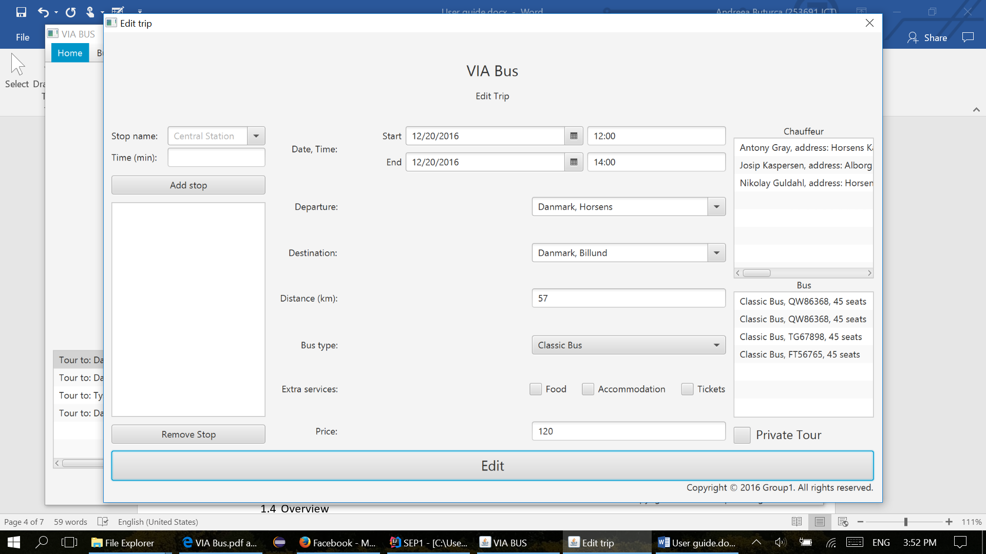

* + 1. Edit reservation

When the user selects edit reservation, a new window will appear on the screen with the same interface like the one in Make Reservation. The user can add new customer, passengers, remove passengers or set new price or discount. To save the changes, it is mandatory to select again the customer from the list.



* 1. Overview

The main page shows in the bottom of the page the list of tours made by the VIA Bus company, sorted by date.



1. Bus List
   1. Bus List

The user must go on the second tab of the menu and select Bus List in order to see all busses, displayed in a list, like the one bellow.

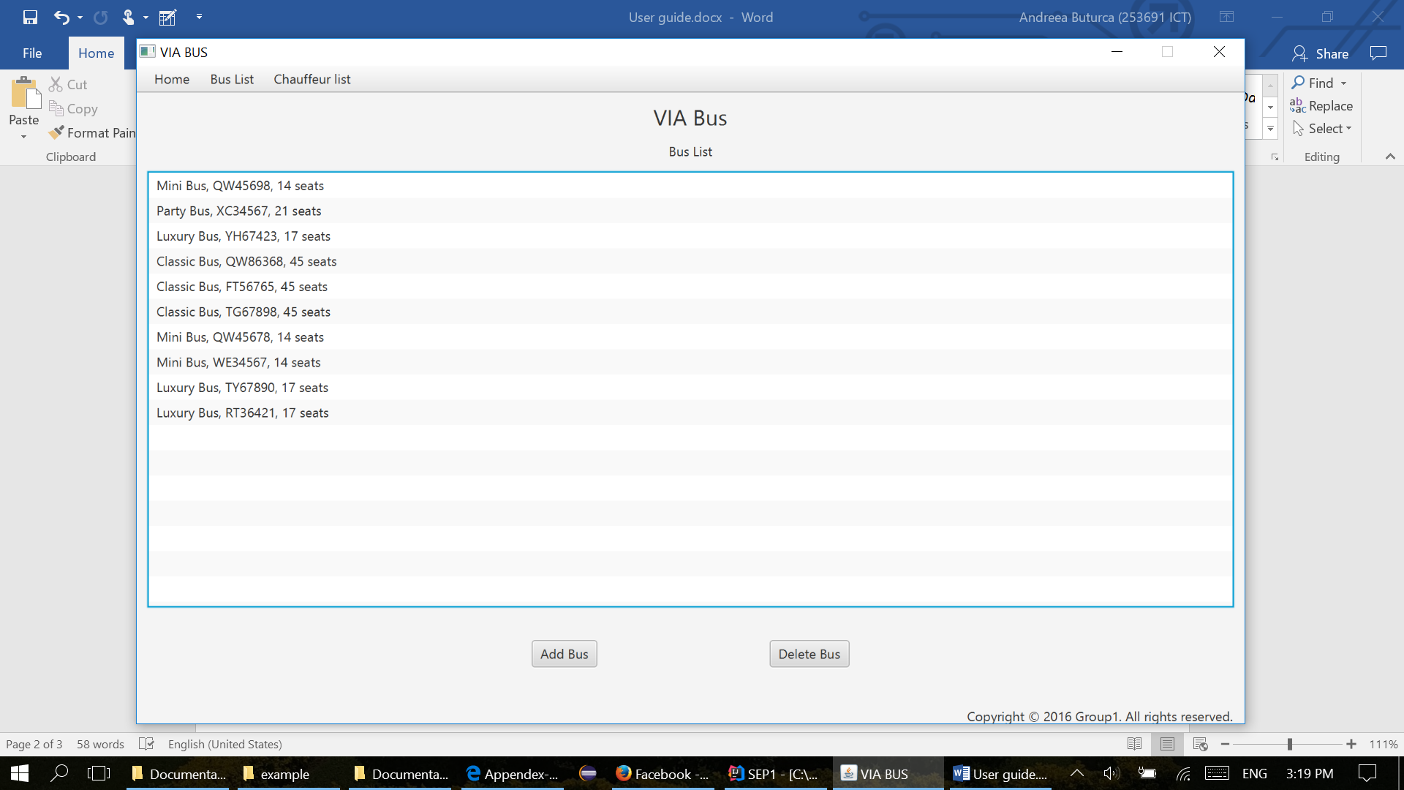

* 1. Add buss

First step, the user must select one of the busses: classic bus, mini bus, party bus or luxury bus.

The second step is to add a registration plate number, which must respect to following format: 2 uppercase letters and 5 digit number (example: AS12345).

Third step: enter the number of seats, per buss.

Last step: press add button.

If one of the above steps it’s not respected, an alert window will appear on the screen, saying which field must be filled properly, otherwise a Succes window will be displayed, showing that the bus was created.

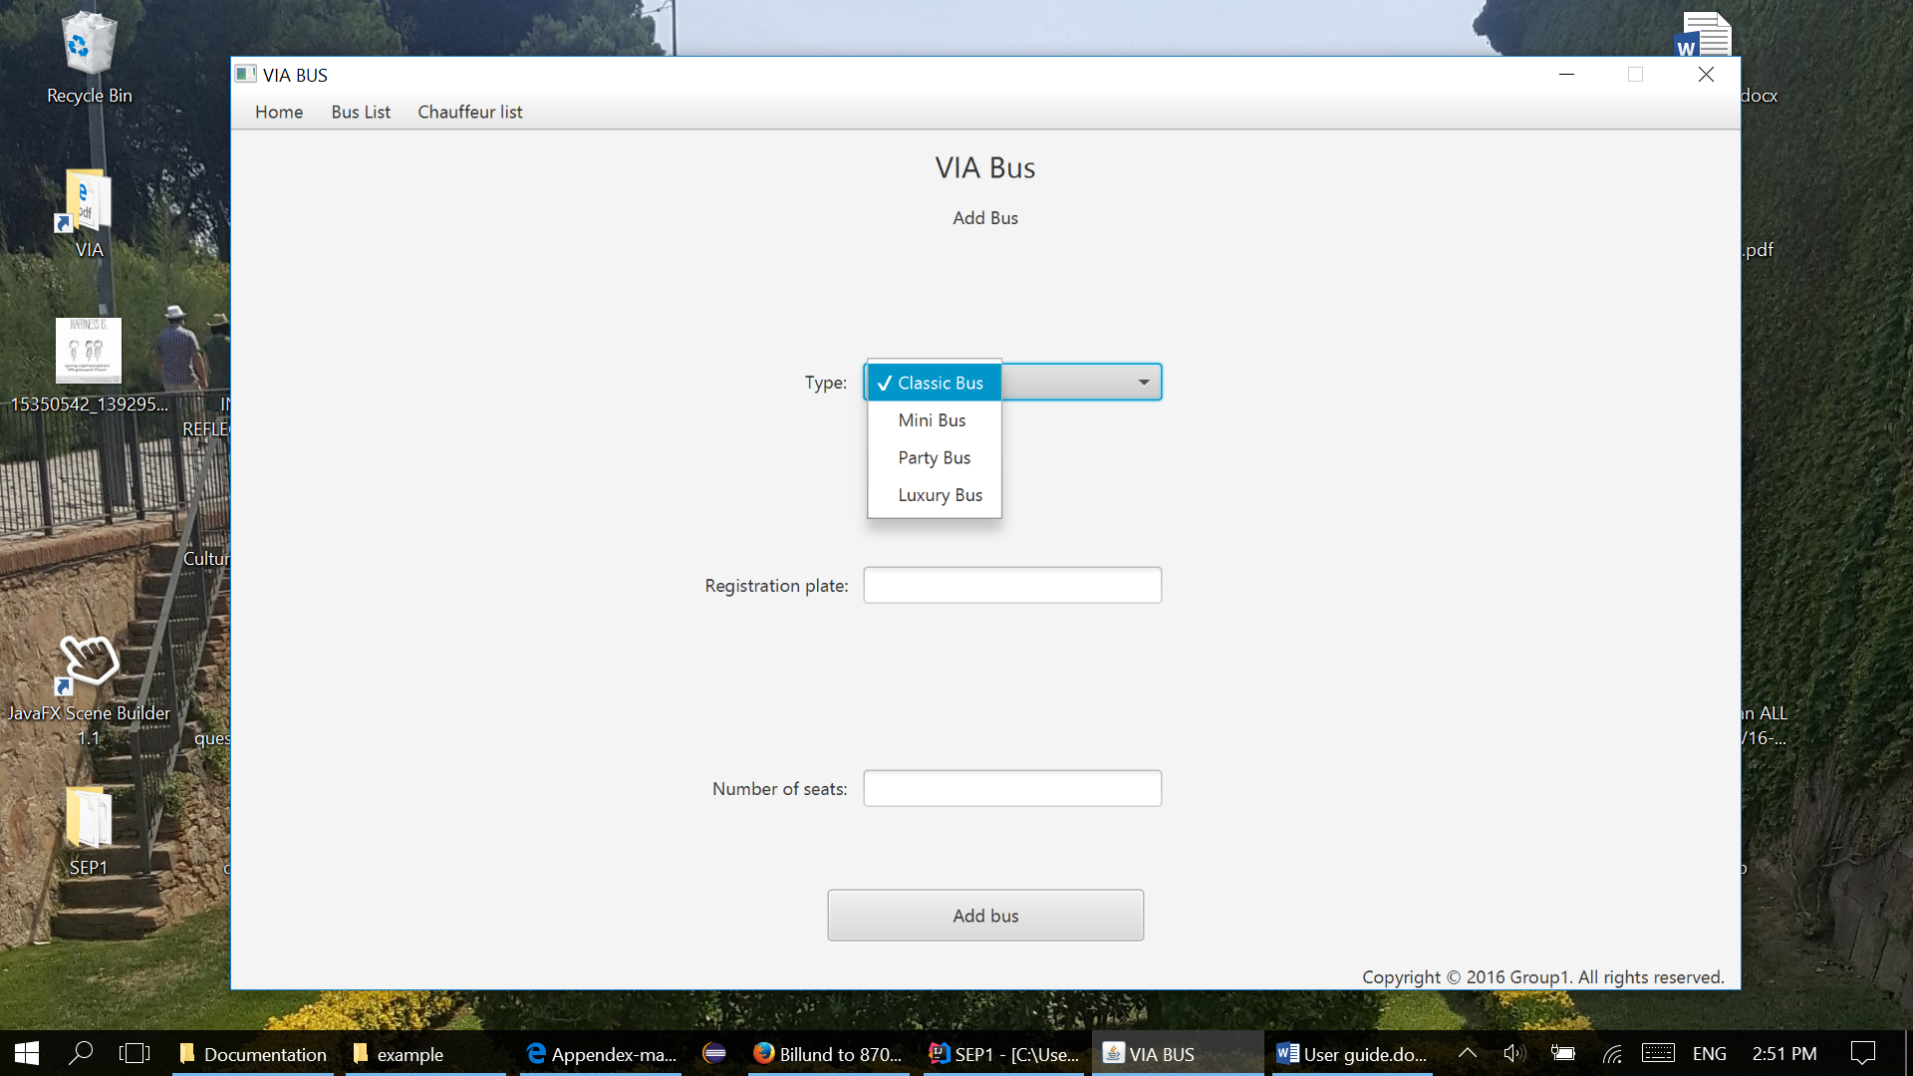

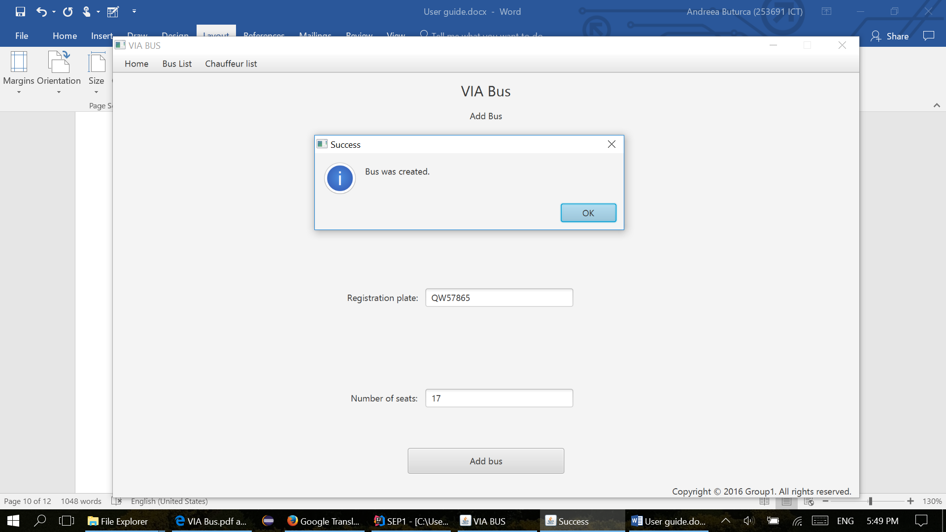

1. Chauffeur List
   1. Chauffeur List

The user must go on the last tab of the menu and select Chauffeur List in order to see all chauffeurs displayed in a list.

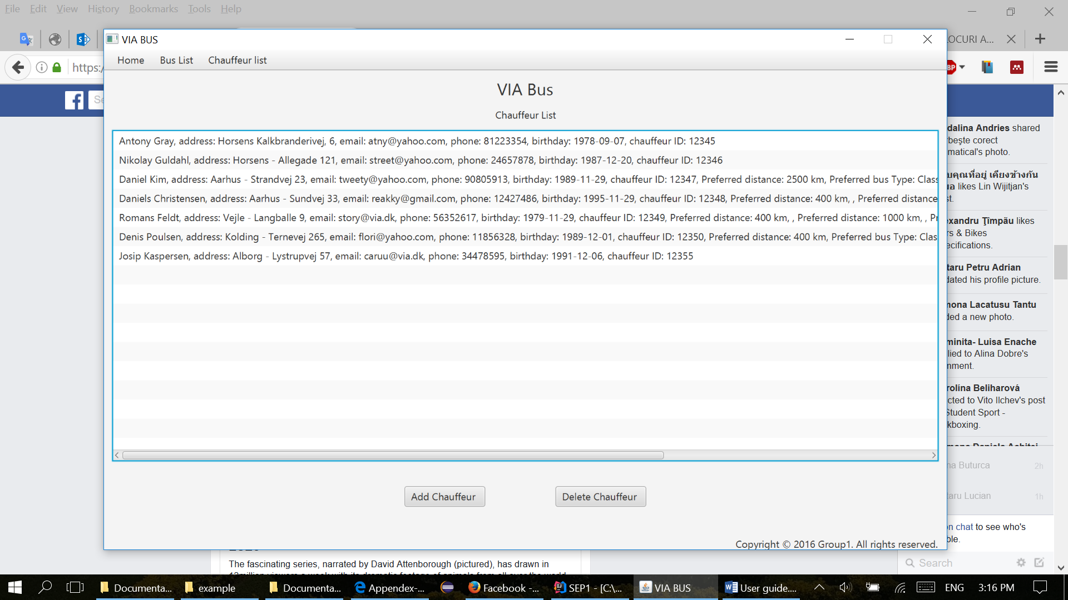

* 1. Add chauffeur

In the Add chauffeur, the user must fill in all the fields with the following mandatory data: name, address, email, phone number (8 digit), date of birthday(can be picked up or filled in with the following format month/day/year), employee ID (5 digit). The user can also select either one, or all the check boxes about chauffeur’s preferrences: distance and bus type. For long distance, the chauffeur prefers only tours with a distance bigger or equal with 2500 km, for medium between 400 and 2500 km and for short distance less, or equal with 400 km. If the user adds a vikar chuffeur, no preferrences are needed to be selected.

